Repositorio GIT

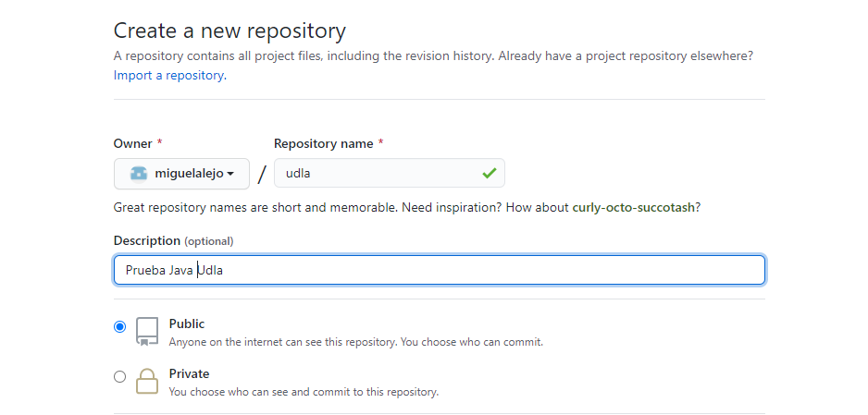

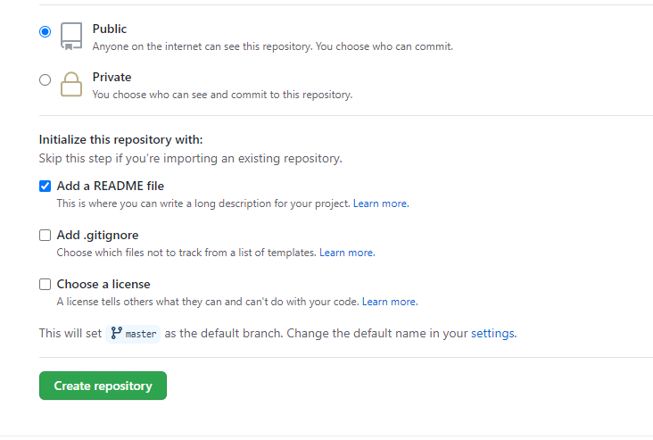

Configuraciones Visual Studio Code

Instalar Plugi in GIT

Installing Spring Tool Suite (STS)